**KL University**



**Department of Computer Science Engineering**

**Course code -17CS2210**

**Database Management Systems**

**II B.Tech – 2nd Semester**

**Academic Year 2018-2019**

**Project Based Skilling**

**ON**

**EVENT MANAGMENT**

**Submitted by**

**Section – S5**

**Batch No: 01**

|  |  |  |
| --- | --- | --- |
| **Student ID** | **Student Name** | **Department** |
| 160030158 | B.Uday Keerthi | CSE |
| 170030055 | A.R.Rajeswari | CSE |
| 170030079 | A.Kesava Sai | CSE |
| 170030092 | A.Baby Mounica | CSE |

**K L University**

**DEPARTMENT OF COMPUTER SCIENCE ENGINEERING**

**(DST-FIST Sponsored Department)**



**CERTIFICATE**

This is to certify that the course based project entitled **“EVENT MANAGEMENT”** is a bonafide workdone by **A.Uday Keerthi(160030158),A.Rajeswari(170030055),A.Kesava Sai(170030079) and A.Baby Mounica(170030092)** in partial fulfillment of the requirement for the award of degree in **BACHELOR OF TECHNOLOGY** in **Computer Science Engineering** during the academic year **2018-2019.**

**Faculty In Charge Head of the Department**

**Mr.Tata Ravi Kumar Mr.V.Hari Kiran**

**DEPARTMENT OF COMPUTER SCIENCE ENGINEERING**

**(DST-FIST Sponsored Department)**



**DECLARATION**

We hereby declare that this project based lab report entitled **“EVENT MANAGEMENT”** has been prepared by **A.Uday Keerthi(160030158),A.Rajeswari(170030055),A.Kesava Sai(170030079) and A.Baby Mounica(170030092)**us in partial fulfillment of the requirement for the award of degree “**BACHELOR OF TECHNOLOGY in COMPUTER SCIENCE ENGINEERING**” during the academic year 2018-2019.

We also declare that this project based lab report is of our own effort and it has not been submitted to any other university for the award of any degree.

**Date: 01-04-2019**

|  |  |
| --- | --- |
| **Name** | **Student ID** |
| **B.U.Keerthi** | **160030158** |
| **A.Rajeswari** | **170030055** |
| **A.Kesava Sai** | **170030079** |
| **A.Baby Mounica** | **170030092** |

**Place: Vaddeswaram**

## 

## 

## ACKNOWLEDGMENTS

Our sincere thanks to **Mr.Tata Ravi Kumar** for the project for their outstanding support throughout the project for the successful completion of the work.

We express our gratitude to  **,** Head of the Department for Computer Science and Engineering for providing us with adequate facilities, ways and means by which we are able to complete this term paper work.

We would like to place on record the deep sense of gratitude to the honourable Vice Chancellor, K L University for providing the necessary facilities to carry the concluded term paper work.

Last but not the least, we thank all Teaching and Non-Teaching Staff of our department and especially my classmates and my friends for their support in the completion of our term paper work.

Table of Contents

Abstract 7

Introduction 8

PROJECT DESCRIPTION 9

List of Entities & Attributes 10

ER Diagram (Conceptual Model) 11

Schema Diagram 12

Normalization & Final List of Relations 13

Create & Insert SQL Queries 14

SQL Queries related to Report Generation 15

Conclusion 16

# Abstract

**Event management** is the application of [project management](https://en.wikipedia.org/wiki/Project_management) to the creation and development of large scale events such as [festivals](https://en.wikipedia.org/wiki/Festival), conferences, ceremonies, formal parties, concerts, or [conventions](https://en.wikipedia.org/wiki/Convention_(meeting)). It involves studying the brand, identifying the [target audience](https://en.wikipedia.org/wiki/Target_audience), devising the event concept, and coordinating the technical aspects before actually launching the event.

The process of planning and coordinating the event is usually referred to as **event planning** and which can include budgeting, scheduling, site selection, acquiring necessary [permits](https://en.wikipedia.org/wiki/License), coordinating transportation and parking, arranging for speakers or entertainers, arranging decor, event security, [catering](https://en.wikipedia.org/wiki/Catering), coordinating with third party vendors, and emergency plans.

The events industry now includes events of all sizes from the [Olympics](https://en.wikipedia.org/wiki/Olympics) down to business breakfast meetings. Many industries, [charitable organizations](https://en.wikipedia.org/wiki/Charitable_organization), and interest groups hold events in order to market themselves, build business relationships, raise money, or celebrate achievement.

# 

# Introduction

  Database is an organized collection of data. The data is typically organized to model aspects of reality in a way that supports processes requiring information. A DBMS makes it possible for end users to create, read, update and delete data in a database. The DBMS essentially serves as an interface between the database and end users or application programs, ensuring that data is consistently organized and remains easily accessible. The DBMS manages three important things: the data, the database engine that allows data to be accessed, locked and modified and the database schema, which defines the database’s logical structure. These three foundational elements help provide concurrency, security, data integrity and uniform administration procedures. The DBMS can offer both logical and physical data independence. That means it can protect users and applications from needing to know where data is stored or having to be concerned about changes to the physical structure of data.

The main purpose of maintaining database for Event management is to provide the following packages to the customer according to their budget and make it convenient for the customers and providers to maintain the data about their customers available at them. The speed of obtaining and processing the data will be fast. For future expansion the proposed system can be web enabled so that clients can make various enquiries about Medicines. It takes a lot of time and causes many errors while data entering. Due to this, sometimes a lot of problems occur and they are facing many disputes with customers. To solve the above problem, we design a data base which includes customer details, availability of packages, list of packages and customers history. This program also helps us to know the present status of a package to the customer that is whether the choosed package is done properly or not and bill received or not.

# PROJECT DESCRIPTION

For the given description, we need to identify major data requirements, entities, attributes, relationships between the entities and to develop ER model and schema diagram by applying normalization techniques and to create tables with constraints to the identified schemas.

# List of Entities & Attributes

Event management - eventId,name,contact,address,packages.

Packages - packageId,no.of guests,furniture,

food,hospitality,accommodation,budget.

Food - foodId,breakfast,lunch,snacks,

dinner,suppliers.

Accomodation - accomodationId,no,of guests,no.of

rooms,A/C or NON-A/C.

Hospitality - hospitatlityId,dance,

singers,orchestra,mimicrie.

Furniture - furnitureId,tables,chairs,

tablecloth,tents.

# ER Diagram (Conceptual Model)

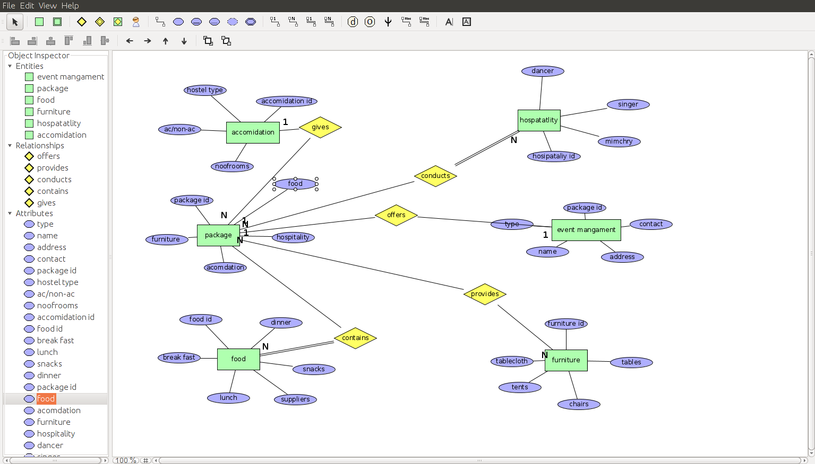

# Schema Diagram

# Normalization & Final List of Relations

1.Event management offers packages

2.packages conduct hospitality

3.packages contain food

4.packages gives accommodation

5.package provides furniture

# **Create & Insert** SQL **Queries**

**create table eventmanagment(event_id int(4),name varchar(20),address varchar(20),contact int(10),primary key(event_id));**

**insert into eventmanagment values(1,'ram','flatno-201,vr appartments'',924545113);**

**insert into eventmanagment values(2,'sai','flatno-202,vr appartments'',924545333);**

**insert into eventmanagment values(3,'seetha','flatno-203,vr appartments'',924545444);**

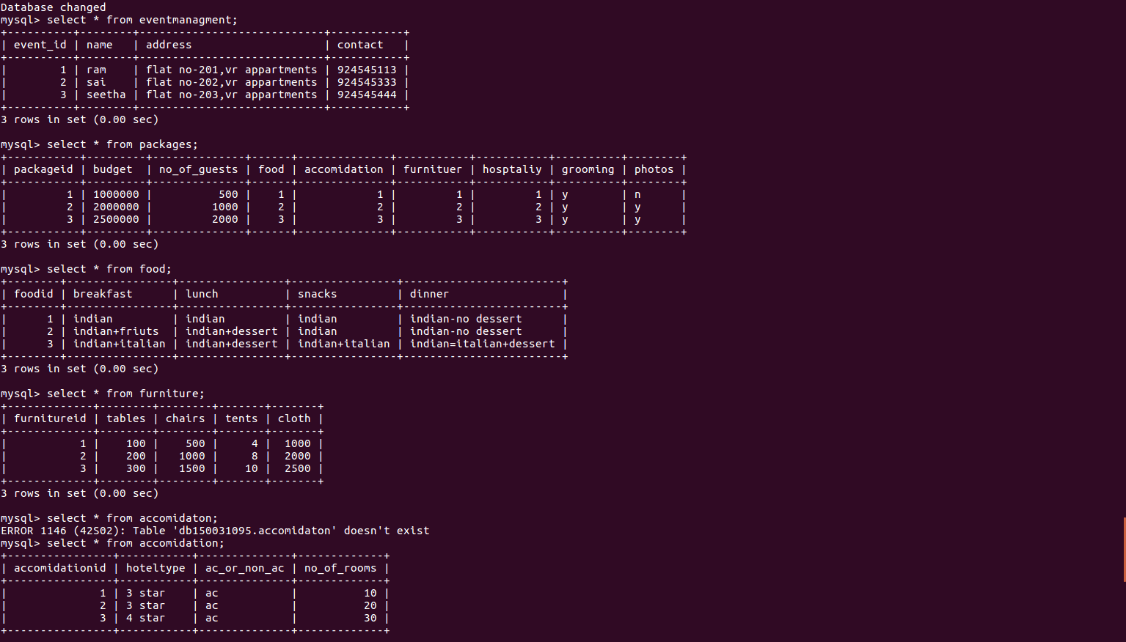

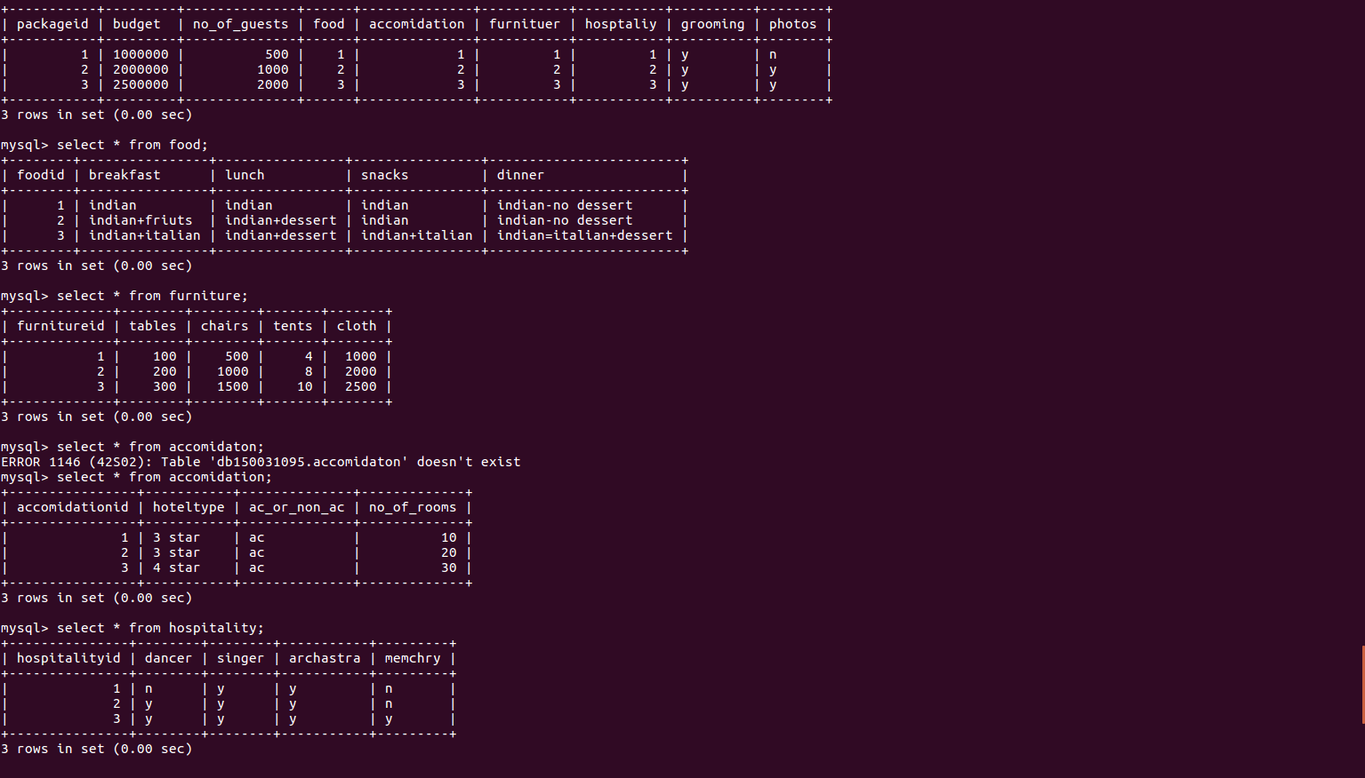 **Conclusion**

Practical Training is a very important part of the curriculum as it strengthens the concepts and enhances knowledge about the practical implementation of all the theory concepts. This project is used to keep a track on tourist’s details in a tour operator system. It helps managing the system very efficiently and conveniently. Initially we have identified the different requirements of our project. Then we divided our module and identified the different tasks of each module. Then we have drawn the ER diagram along with the relationships associated. We identified the tables from ER- diagrams and found the different attributes associated with each table. We created the tables with appropriate integrity constraints for each and every table. We inserted records into all the tables created .Then we wrote different queries to retrieve the data from database to satisfy the different tasks .Thus we accomplished every task given in each and every module.